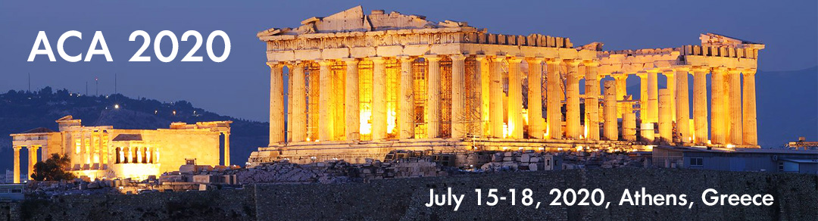
ACA 2020
Athens (Greece) July 15 – 18, 2020
Computer algebra modeling in science and engineering
Special Session at the 26th International Conference on Applications of Computer Algebra (ACA’2020), July 15 – 18, 2020, Athens, Greece
Aim and scope
The progressive impact of the Computer Algebra Systems (CAS) in science-based disciplines vividly is noticeable. It is rare to encounter a scientific investigation that is immune from its beneficial influences. Symbolic capabilities of the CAS provides forum to perform amazing calculations that practically are impossible otherwise. Within the last 25 years, applications of the CAS are extended beyond the peculiarities of scientific disciplines such as: biology, chemistry, microbiology, and physics, and has become the tool of the choice for analyzing engineering and mathematical challenging problems. For instance, dynamic simulations of engineering issues are addressed and mathematical conjectures are formulated and verified. Applications of the CAS lend it beyond the researchers' tools and have become powerful pedagogical instruments. The latter is suitable to engage the computer savvy generation promoting the discipline of interest.
The purpose of organizing this session is to bring together enthusiastic users of the Computer Algebra Systems in science and engineering. Expected topics of presentations include (but are not limited to):
♦ symbolic and numerical methods solving ODEs
♦ modeling and simulation in physics
♦ simulation of quantum computation
♦ perturbation theories
♦ applications in biology, chemistry, and microbiology
♦ modeling in finance and economics

Organizers
Alexander Prokopenya, ⟨alexander_prokopenya@sggw.pl⟩
Institute of Information Technology,
Warsaw University of Life Sciences – SGGW, Poland
Haiduke Sarafian, ⟨has2@psu.edu⟩
Professor of Physics and
Endowed Chair of John T. and Paige S. Smith Professor of Science
The Pennsylvania State University, USA
Submissions
If you are interested in presenting a talk, please email an abstract to either one of the organizers. Please use LaTeX template for your abstract that is available at the conference website. Each presentation including Q&A is 30 minutes. Tentative abstract submission deadline is April 23, 2020; early submissions are appreciated. More than one abstract may be submitted.

Detailed information about the session is posted
at the ACA2020 conference web page
https://aca2020.sba-research.org

